China’s investment in Africa: What we need to know

By Sombo M. Chunda & Prof. Van R. Wood, Virginia Commonwealth University

2017

Abstract
China continues to expand its influence on the African continent. In 2000, the Forum on China-Africa Cooperation (FOCAC) was established to enhance and revitalize; trade, investment, infrastructure and capacity building. Cooperation in finance and tourism has also expanded forming a multi-tired and wide-ranging pattern of interaction. This pattern is different from the approach of earlier periods (particularly the 1950s) which centered on bilateral trade and China's aid to Africa. In 2009, China became the continents number one trade partner. Trade between China and Africa reached US $198.49 billion in 2012, a year on year growth of 19.3%. Approximately US$85.319 billion consisted of China's exports to Africa and US$113.171 billion represented China's imports from Africa (China- Africa Research Institute, 2017). As the China-Africa partnership grows these numbers are expected to expand dramatically. This paper discusses the pertinent aspects of China's investment in Africa as a necessary conversation in view of the changing global economic and power dynamics of both parties.

Key words: Investment; China; Africa

Introduction
China's investment in Africa is a topical issue. Much has been written about Chinese investment in Africa and the impact it has on the economic growth of the continent. This conversation has had one cardinal part missing. How Africa relates to China. The absence of data and information on this other side to the discussion of China in Africa gives reason to believe those that say what is being witnessed is the second scramble for Africa. China’s plan for its cooperation with Africa is clear and the country’s white paper details that (Information Office of the State Council of the People’s Republic of China, 2017). On the other hand, there is no guiding paper on Africa’s cooperation with China. Due to the complex nature of the continent with its 54 distinct sovereign countries. A key question thus arises - would the development of a plan on cooperation with China be the responsibility of the African Union, or each respective country in Africa or that of China?
It is evident that China is the lead in this cooperation. While the FOCAC lays the operational plan of China’s intentions in Africa, some observers believe Africa to be a taker and China the giver in this relationship. Again, this paper highlights the key features of Chinese investment in Africa. We call for research into what we need to know concerning Africa’s cooperation with China. This is an important aspect of the relationship between China and Africa that needs deliberate efforts by scholars to obtain a clearer understanding of China’s investment in Africa.

Why is China in Africa? The quest for resources, vast and wide- deep into the hinterland

Africa’s total land area is approximately 11,724,000 square miles (30,365,000 square km), and the continent measures almost 5,000 miles (8,000 km) from north to south and 4,600 miles (7,400 km) from east to west. The continent has a great diversity of biological resources that includes the intensely lush equatorial rainforests of Central Africa and the world-famous populations of wildlife of the eastern and southern portions of the continent. Although agriculture (primarily subsistence) still dominates the economies of many African countries, the exploitation of African natural resources became the most significant economic activity in Africa in the 20th century (French, 2014). Indeed, Africa contains an enormous wealth of mineral resources, including some of the world’s largest reserves of fossil fuels, metallic ores, and gems and precious metals. The map below gives a broad overview of this wealth and where it is located.
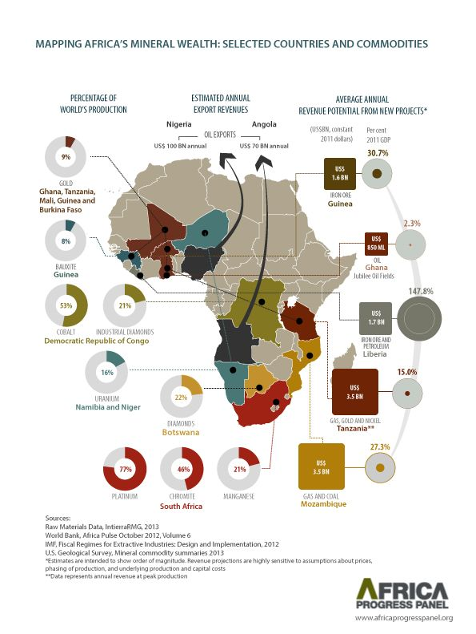Source: Africa Progress Panel (2013)
For a significant period, Chinese investment in Africa has been motivated by a desire to access critical resources (oil, bauxite, etc.). The Chinese approach has been to downplay political issues (e.g., human rights). Likewise, although recipient African nations have received investment inflows from the Chinese, these investments have come with certain drawbacks. Specifically, they have negatively impacted local trade and commerce (Adisu, Sharkey and Okoroafo, 2010). Despite this, China has managed to create a good image of itself in Africa relative to elsewhere in the world. In a recent Global Attitudes survey, African respondents had a significantly positive view of China with 70% giving a favorable view (Pew Research, 2015). Respondents in other regions of the world polled less -favorability of China as follows; Europe 41%; Asia 57% and Latin America with 57%.
China’s investment in Africa includes some large deals that have been highly publicized (Chen, Dollar and Tang, 2015). In the Democratic Republic of Congo, for example, the Sicomines iron mine involves the Chinese state-owned enterprises China Railway Engineering Corporation and Sinohydro, and the private company Zhejiang Huayou Cobalt, in partnership with Congolese state-owned companies. Other high-profile deals include CNPC’s gas investment in Mozambique, Chinalco’s mining investment in Guinea, and Sinopec’s oil and gas acquisition in Angola (Chen et al, 2015).

China in Africa- opportunity or threat?

China’s presence on the African continent and its future interest can be seen as both an opportunity and a threat. After launching its historic opening (its “turnaround”) during the middle to late 1970’s (the late Chinese leader – Deng Xiaoping expressed this embrace of any economic system that creates wealth as – “black cat, white cat, it does not matter as long as it catches mice”), China went from being a poor society with an economy that produced few goods for export and imported little, to positioning itself as the so-called factory of the world as we recognize it today (French, 2014).
The question for Africa and African countries today is - are China’s intentions clear and could they be useful in the “turnaround” that the African continent (much like China in the 1970s) is experiencing today? To answer this, it is useful to examine a “White Paper” that now guides the Chinese, in their approach and actions with Africa (Information Office of the State Council of the People’s Republic of China, 2017). This White Paper expresses six strategic goals, including:
- Promoting sustainable development of trade
- Improving the level of Investment and Financing Cooperation
- Strengthening Cooperation in Agriculture and Food Security
- Supporting African Infrastructure Construction
- Stressing African People’s Livelihoods and Capacity Building and
- Promoting Cooperation under the Multilateral Framework.
Guided by these goals, China has over the last 20 years grown to become Africa’s largest trading partner. The trade between Africa and China has been growing at approximately 20 per cent per-year and foreign direct investment has grown even faster, particularly over the past decade, where an annual growth rate of 40 percent has been witnessed. Trade between China and Africa reached US $198.49 billion in 2012 (China- Africa Research Institute, 2017). Approximately US$85.319 billion consisted of China's exports to Africa and US$113.171 billion was contributed by China's imports from Africa. China is also financing numerous infrastructure projects in Africa. Likewise, Chinese investments in Africa now spans across many economic sectors including agriculture, energy, finance, metals (mining), real estate, technology, tourism, transport and utilities among others. Between 1998 and 2012, China was said to be operating in 25 sectors in Africa (McKinsey, 2017).
Distribution of Chinese deals by sector: 1998-2012
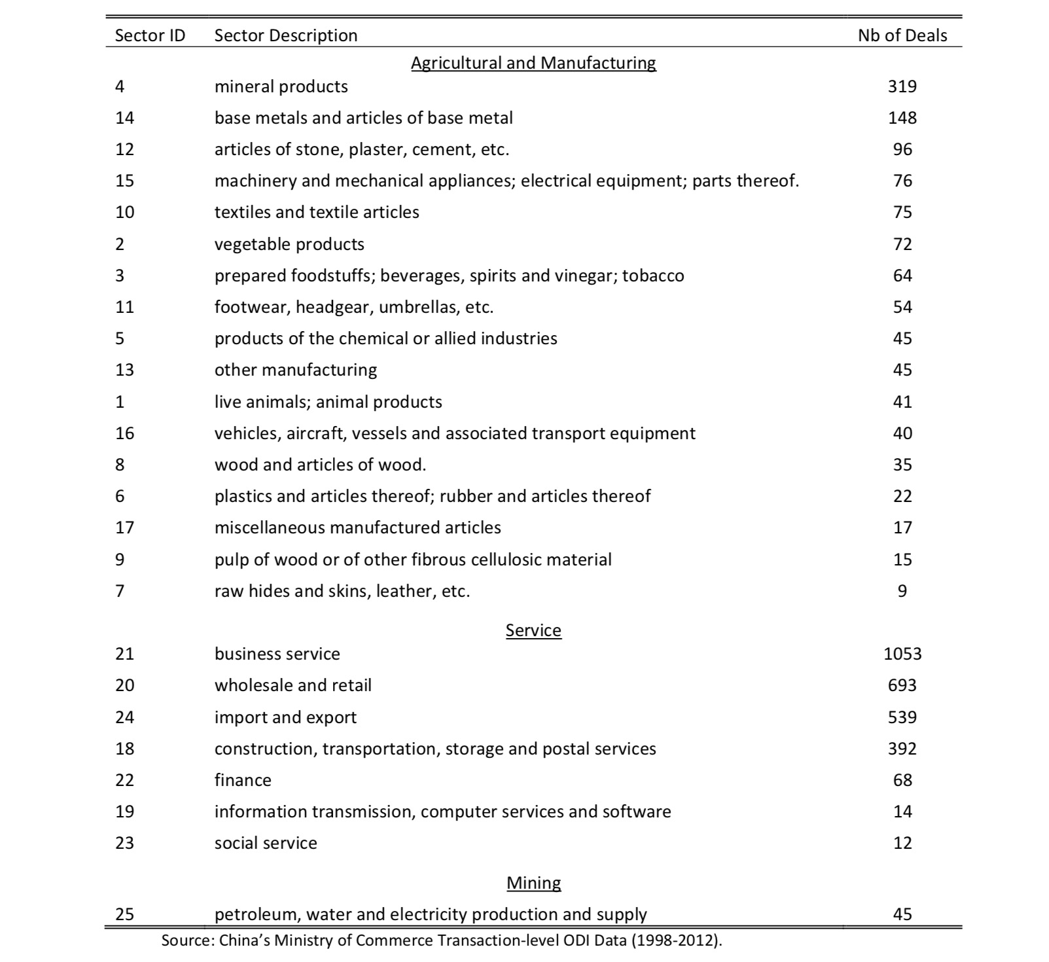There are voices that have cautioned China, Africa and the entire world on China’s activities in Africa. In 2011, then United States Secretary of State Hillary Clinton made these remarks ‘we do not want a new colonialism in Africa, when people come to make investments in Africa, we want them to do well, but we also want them to do good. We do not want them to undermine good governance in Africa’ (Reuters, 2011). While there is no known conflict started by China on the African continent, there are, however, several reports of human rights abuse. In 2005 nearly 50 Zambians lost their lives in an accident at a Chinese owned explosives plant on the Copperbelt Province (British Broadcasting Corporation, 2005) and in 2010, Chinese mine supervisors shot and wounded 11 Zambians following a dispute at a mine site (The Telegraph, 2010). There are many other cases that give reason to question the Africa-China relationship – is it mutually beneficial or is it a power play and the part of the Chinese?

Africa’s fascination with China: A Backlash to the West?
China is not only Africa’s largest trading partner; it is also a friend that gives big gifts. Many countries in Africa have been recipients of roads, sports stadiums and buildings constructed by China at no cost to the country. In 2011, China gave the continent the new headquarters of the African Union, a 20- story building in Addis Ababa Ethiopia valued at $200 million (United Nations, 2013). By pouring $2.25 billion into Africa annually, China has positioned itself as a viable, and often more attractive, alternative to traditional Western aid and development organizations (Ahmadi T, 2017) . Chinese money is accompanied by a policy of no interference, meaning few strings are attached for the recipient country (again, no demands for respect of human rights) besides access to natural resources or a local market. Unlike Western money that often comes with conditionalities, like enforcing good governance, human rights or environmental protection, Chinese’ aid is doled out efficiently and projects are often completed on schedule or earlier.
Their non-interference policy also means that the Chinese are willing to indulge African despots that many Western development organizations dare not. China’s official policy statement on its trade and aid relationship with African nations states that as a first principle, China “respects African countries’ choice in political system and development path suited to their own national conditions, does not interfere in internal affairs of African countries, and supports them in their just struggles for safeguarding their independence, sovereignty and territorial integrity.” (Condon M, 2012). China is presenting itself as a champion of the East and an alternative option (to the West) for financing the development of emerging economies. While characteristics of China’s foreign policy are accurately likened to economic exploitation, it appears China’s deeper goal in Africa is to forge lasting partnerships in exchange for political loyalty. This may also be influenced by the fact that the longevity of the Sino-African “win, win” relationship is contingent on the Chinese economy’s success (Ahmadi T, 2017).

China’s integration in Africa

Many Chinese immigrants have actively passed information to their fellow nationals about Africa as observed in the book China’s Second Continent: How a million migrants are building a new empire in Africa (French, 2014). There are an estimated 1 million Chinese nationals in Africa with more than 10,000 companies owned by the Chinese on the continent (McKinsey Africa, 2017). Likewise, mainland China has been instrumental in supporting the integration of Chinese nationals on the continent. In 1997, China opened its first financial institution in Africa, the Bank of China in Lusaka, Zambia. The bank is a facilitator of numerous business transactions including corporate and personal services, credit facility, account services, international settlement, exchange services, Chinese RMB services, and so on (Bloomberg, 2017).
In early 2012 China Central Television (CCTV) opened a broadcast hub in Nairobi, Kenya — its first outside of its Beijing headquarters. Its strategy has been to hire some of Africa’s brightest journalists to report on Africa to viewers in over 170 countries (United Nations, 2013). A recent study of Chinese integration in Zambia concludes that contrary to previous claims that Chinese nationals are ethnocentric, the opposite is true (China -Africa Research Institute, 2017). The report concludes that third parties, especially USA politicians and media, should recognize that the myths about how Chinese interact with Africans are becoming obsolete. As more young- broadly skilled Chinese come to the continent and as Chinese adaptation deepens, third party actors will have to choose whether to maintain a propagandistic discourse about China in Africa or acknowledge that it has been a politically- driven exercise in mis-direction.

Conclusion

China is not new in Africa. The new global developments have propelled China’s investment in Africa to be more visible. The political shifts in the United States of America and Europe as well as information technology have contributed in bringing to the agenda the China- Africa investment story. This big successful story will only be complete when we know what we currently do not know with respect to the Africa- China relationship and what it is truly all about. This is a mammoth task considering among other factors, the lack of transparency by most governments in Africa and other impediments such as the cultural, linguistic and ethnic diversity in Africa that may make assessment of the current realities and long-term meaning of the African – Chinese relationship difficult. Non-the-less, it is a necessary area of research that if conducted in such a way as to be both insightful and prescriptive can inform governments and the people of Africa what the true benefits are in the increasingly strong partnership with China.

References

Adisu. K, Sharkey. T and Okoroafo. S (2010). The Impact of Chinese Investment in Africa.
Condon. M (2012) China in Africa: What the Policy of Nonintervention Adds to the Western Development Dilemma.
Chen. W, Dollar.D and Tang .H (2015). Why is China investing in Africa? Evidence from the firm level.
Chen, Yunnan, Sun. I, Ukaejiofo. R, and Brautigam. D (2016) , Learning from China? Manufacturing investment and technology transfer in Nigeria, Johns Hopkins University School of Advanced International Studies China-Africa Research Initiative (SASI-CARI) working paper 2.
Howard W. French (2014). China's Second Continent. How a million
migrants are building a new empire in Africa.

Lu Yao, Barry Sautman, Yan Hairong, and Zhou Weixuan (2017) Adaptation of Chinese immigrants in Zambia
Ministry of Commerce of China and National. 2012. Statistical Bulletin of China’s Outward Foreign Direct Investment, Beijing: China Statistics Press
Quinn, Andrew and Mark Heinrich. 2011. Clinton warns against "new colonialism" in Africa. Reuters. Accessed September 22, 2017 http://www.reuters.com/article/us-clinton-africa/clinton-warns-against-new-colonialism-in-africa-idUSTRE75A0RI20110611
http://www.africaprogresspanel.org/wp-content/uploads/2013/08/2013_APR_Equity_in_Extractives_25062013_ENG_HR.pdf

https://www.bloomberg.com/research/stocks/private/snapshot.asp?privcapId=145314663
http://www.china.org.cn/government/whitepaper/node_7189938.htm
https://chinapower.csis.org/global-views/
http://www.mckinsey.com/global-themes/middle-east-and-africa/the-closest-look-yet-at-chinese-economic-engagement-in-africa?cid=soc-web

http://news.bbc.co.uk/2/hi/africa/4466321.stm

http://www.telegraph.co.uk/news/worldnews/africaandindianocean/zambia/8073443/Zambian-miners-shot-by-Chinese-managers.html
Ahmadi T (2017). China’s Strategic African Exploitation. http://the-generation.net/chinas-strategic-african-exploitation/
http://www.un.org/africarenewal/magazine/january-2013/china-heart-africa

