This paper is a part of my PhD research in the University of Northampton, United Kingdom funded by the Tertiary Education Trust Fund of Nigeria.

1. Introduction
The topic of the role of entrepreneurship education (EE) in contributing to the nations’ growth and development has grown in importance in light of research findings affirming this assertion. Accordingly, there is growing emphasis on the role that universities play in the growth of entrepreneurship through education (Jones, Jones, Skinner and Packham, 2013). This is particularly important to this study since it is an evaluation of a compulsory entrepreneurship module offered in Nigerian universities and how culture impacts on the attainment of its main objective. The specific area of concentration in this study, is the appraisal of the influence that culture has on the entrepreneurial intentions of a cohort of Nigerian university graduates who have participated in the compulsory entrepreneurship module. The aim of the EE programme in the Nigerian context is to develop in graduates, entrepreneurial mind-sets that will enable them choose self-employment (own business) as career paths instead of searching for paid employments and being in the job market for several years after graduation.
Entrepreneurial intention is influenced by several factors and these factors differ from culture to culture (Mitchell, Morsem, Seawright, Peredo and McKenzie, 2002). Thus, making the overall effect of culture on entrepreneurship unclear. Because of the differences in the entrepreneurial activities across diverse cultures, it has been suggested that the examination of how culture relates to the level of entrepreneurial activity is both of practical and theoretical importance (Hayton, George and Zahra, 2002). This being so, a growing body of literature have identified that culture play significant role in the decision to create new ventures and further viewed as critical to the development of entrepreneurial intentions (Francisco, Ghulam and Krueger, 2013). This portrays culture as one of the factors that can either promote or hinder entrepreneurship. There is on-going debate on the role of culture in fostering entrepreneurial mind-set among entrepreneurship researchers. However, culture is not generally accepted as a determinant of entrepreneurship (Thurik and Dejardin, 2012). Despite the on-going discussion in relation to the relationship between culture and entrepreneurship, most studies in the field have focussed on entrepreneurial culture. While some studies have been carried out on the effect of culture on entrepreneurship in the western world, there have been only very limited investigated on the subject in the developing world context thus, creating a gap that this study fills. In this study, culture is examined from the perspectives of both national culture and subjective norm.
Culture supportive of entrepreneurship could result to higher entrepreneurial intentions among the populace thus, more new ventures would be created and additionally, assist the acceptability and legitimacy of entrepreneurship (Linan and Chen, 2009; Etzioni, 1987). Explaining the determinants of entrepreneurial intentions is therefore central to the discipline of entrepreneurship and the comparative constancy in the differences found in groups of countries suggests that other factors besides economic factors like culture might provide other explanatory factors as to the causes of these differences (Freytag and Thurik, 2010). For example, in 2007 one out of eight persons among the working population in the UK were self-employed while the number was one out of ten in the French working population (Thurik and Dejardin, 2011). Variations in self-employment or entrepreneurship are associated with either the level of technological or economic development however, the differences occurring across countries seem rather to emanate from cultural or institutional contexts (Thurik and Dejardin, 2011). Entrepreneurship in many arenas are measured by the number of new ventures created and the magnitude of self-employment. So, the simple question of what drives people to engage in entrepreneurship have been and continues to be a subject of investigation.
This paper is organised as follows. The next part provides a synopsis of the research context. The next section discusses the theoretical underpinning of the study and presents the conceptual model of entrepreneurial intention adopted including the hypotheses developed for the study. Thereafter, the methodology section explains the sample and the procedures used. Next is the results section that reports on the structural equation model analysis. This is followed by a discussion section. The paper concludes by providing a conclusion, the implication of the research, the limitation and future research.
2. Research Context
Nigeria, the context of this study is in the West African sub-region. The current population of the current is about 183 million and more than half of its population are below 30 years of age (National Population Commission, 2017). One in every two West African is a Nigerian, one in every five-persons of African descent is a Nigerian and a large part of West African economic activity is concentrated in Nigeria (OECD, 2012; Yusuf & Schindehutte, 2000) and it is the largest black nation on earth. Although, the country is highly dependent on oil exports and struggles to meet with domestic energy demands, it possesses great industrial potential (OECD, 2012) waiting to be explored. The country has over 250 ethnic groups with different languages and cultures making it rich and outstanding in ethnic diversity. The official language is English and used in all governmental interactions. It is also the language of instructions in all educational institutions and the mode of communication in formal business transactions (Okpara and Kabongo, 2011).

3. Theoretical and Conceptual Framework
Different theories have been suggested in previous literature for explaining the creation of new ventures. Guerrero, Rialp and Urbano (2008) identified the most used models for testing entrepreneurial intention as Ajzen (1991) theory of planned behaviour (TPB); Shapero (1982) entrepreneurial event (SEE) and Robinson, Stimpson, Huefner and Hunt (1991) entrepreneurial orientation. Others are Davidsson (1995) Davidsson model, entrepreneurial potential model Krueger and Brazeal (1994) and Krueger (1994) and the intention basic model.
The theory of planned behaviour as Ajzen (1991) postulates, holds that human actions are guided by three types of considerations:
Attitude towards a behaviour (PA) and in this study the behaviour is entrepreneurship. PA denotes the extent to which an individual holds a positive or negative personal appraisal of self-employment. This construct of the TPB encapsulates both the affective (likeness) and evaluative considerations (benefits derivable) that the individual associates with being an entrepreneur (Linan and Chen, 2009). The theory further theorises that the more favourable the PA and SN, with respect to behaviour, the higher the perceived behavioural control (PBC) should be and in turn the stronger the individual’s intention to perform the behaviour of consideration (Ajzen, 1991).
Perceived behavioural control (PBC) signifies the perception of an individual of the ease or difficulty of engaging in self-employment. This construct (the PBC) includes the perception of ability and control that a person has of entrepreneurship. This concept is similar though not the same as Shapero and Sokol, (1982) perceived feasibility and identical to Bandura (1997) self-efficacy.
Subjective Norm (SN) denotes the perception of an individual of the pressure from the ‘significant others’ in their lives to engage or not engage in entrepreneurship or become an entrepreneur. All three concepts relate to the sense of people’s ability in terms of new venture creature (Linan and Chen, 2009). Several studies support the use of the applicability of the TPB to entrepreneurship study although there have been conflicting outcomes between various studies (Linan and Chen, 2009) some of which are attributed to the differences in the measures used (Chandler and Lyon, 2001). This study derives from the theory of planned behaviour (TPB).
Of the six main theories identified by Guerrero, et al (2008), the theory of planned behaviour (TPB) stands out being the most commonly applied in the field entrepreneurship in general and in entrepreneurial intention studies in particular. The TPB is preferred because of its ability and efficacy in predicting EI which has been demonstrated in several studies (Karimi, Biemans, Lans, Chizari, and Mulder, 2014; Linan and Chen, 2009; Kolvereid and Isasken, 2006; Krueger, et al., 2000). Furthermore, the theory has been applied in diverse fields for testing intentions. This theory is preferred of all the theories having been tested and validated and amenable to the addition of constructs that can predict intention (Krueger, et al., 2000; Ajzen, 1991).
The choice of engaging in self-employment is considered as conscious and voluntary Krueger, Reilly and Carsrud (2000). Therefore, analysing how the decision to become an entrepreneur is taken, becomes a subject of importance (Linan and Chen, 2009). Some authors have argued that the intention to engage in entrepreneurial activities are perhaps affected by factors that include beliefs, needs and values (Lee and Wong, 2004; Bird, 1988). Culture is widely accepted as a determinant of entrepreneurship and there is an on-going debate that it is instrumental to the development of entrepreneurial intention (Thurik and Dejardin, 2012). For example, cultures that support and value entrepreneurial activities might enable radical innovation and more risk-taking, whereas cultures that emphasise and strengthen conformity (public service) and control over the future will be less likely to support entrepreneurial activities (Hayton, et al., 2002). This is evident bearing in mind that while some countries, for instance the US, encourage risk-taking attitudes, some other countries do not (Stephan, 2008; Henry, et al., 2003). In contrast, Nigeria is a country where loyalty to family, age group, immediate community and respect to elders and superior takes priority over most societal rules and regulations and this makes it differ from western cultures (Okpara and Kabongo, 2011). It is no wonder therefore, that in 2004, Hofstede in Okpara and Kabongo (2011) classified Nigeria as a collectivist country where people value close and long-term commitment to family, extended families and relationships.
4. Data Collection and Methodology
Data for this study was collected through a survey of a sample of university graduates from six federal universities in the north central geo-political zone of Nigeria. The six universities have the same ownership, facilities are provided using the same parameters, similar students’ enrolment, similar scheme of work etc.
4.1. Hypothesised Relationships
This study began with a comprehensive proposed conceptual model that includes the key elements of the TPB excluding the perceived behavioural control (PBC) because some of its elements are found in EI. The proposed conceptual model incorporates the antecedent variables of culture (Linan, et al., 2013). I develop from this model, depicted as Figure 1, the hypotheses of the study with a sample of 409 fresh Nigerian university graduates to determine the extent to which culture and subjective norm affect the development of entrepreneurial intentions.

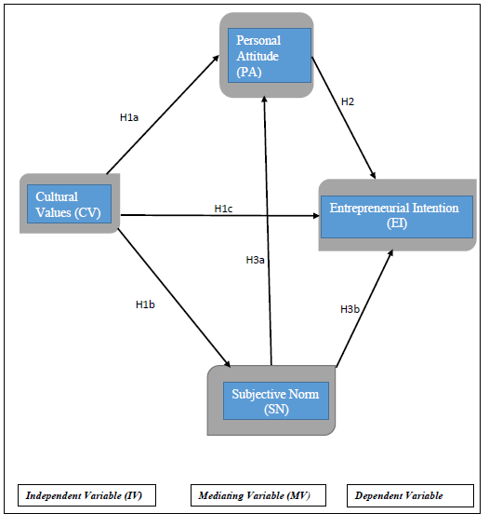
Fig. 1: Proposed Conceptual Framework and Hypothesised Relationships

4.2. Culture and Entrepreneurial Intentions: Evidence from prior literature indicate that culture stimulates individuals to participate in activities that may well not be apparent in other communities (George and Zahra, 2002). Similarly, culture has been found to influence the development entrepreneurial intentions (Linan, et al., 2013). In this sense, cultural values and practices might wield inspiration on entrepreneurial path either positively or negatively (Linan, et al., 2013). For example, the analysis of Stephan (2008) showed that the more a culture legitimises entrepreneurship, the greater the members of the community develop entrepreneurially. The development of entrepreneurial intention does not therefore depend on the education of the graduates alone but also has more to do with the culture of the people. As a result of this, and to further advance knowledge in this aspect, I therefore suggest the following hypothesis:
H1a: The effect of culture on entrepreneurial intentions is mediated by personal attitude
H1b: The effect of culture on entrepreneurial intention is mediated by subjective norm
H1c: Culture has direct positive effect on entrepreneurial intention
4.3. Personal Attitude and Entrepreneurial Intention: Personal attitude, one of the constructs of the theory of planned behaviour refer to the extent to which a person holds a positive or negative perception about new venture creation (Ajzen, 1991). As Linan, 2004 has written the more favourable an individual’s antecedents (personal attitude) to entrepreneurial activities, the more would be the intention to engage in entrepreneurship. In terms of planned behaviour which includes engagement in entrepreneurial activities, intention precedes a target behaviour (Sequeira, Mueller and McGee (2007). Therefore, I develop the following hypothesis to reflect a relationship between attitude and intention.
H2: Personal Attitude has positive significant relationship with Entrepreneurial Intentions
4.4. Subjective Norm and Entrepreneurial Intentions: Following the seminal work of Ajzen (1991) that ‘subjective norm has direct positive effect on Entrepreneurial intentions, I develop the third hypothesis. In the field of entrepreneurship this hypothesis has had diverse impacts (negative, positive, no impacts in EI) in previous studies to the extent that some studies have excluded the analysis of SN. Indeed, the seminal work of Ajzen (1991) earlier referred to, found subjective norm not to have impact on entrepreneurial intentions. Nevertheless, some other studies have reported SN to be significant in predicting entrepreneurial intentions in certain contexts. For example, SN was reported to significantly explain entrepreneurial intentions in the studies of Kolvereid and Isaksen, (2006) and Tkachev and Kolveried, (1999). In contrast, Autio, Keeley, Klofsten, Parker and Hay (2001) and Krueger et al (2000) found SN to be insignificant in their studies. Despite the contracting findings of prior studies, there is still evidence to support a direct relationship between SN and EI. Recent evidence however, suggests that social norm may be highly context dependent (Brownson, 2014) therefore, its effect requires investigation in different contexts to determine its impact.
To redress this situation, Linan and Chen (2009) proposed the investigation of the indirect effect option of SN on EI through PA. The authors further wrote that reasons could abound as to why both PA, PBC could mediate SN to EI. Furthermore, SN refers to the perceived pressure from the significant others in people’s lives to either engage or not to engage in entrepreneurial activities; to this end, the influence of culture is feasibly stronger on motivational antecedent (Kristiansen & Indarti, 2004; Bagley & Tan, 2001), hence I developed hypothesis 3a and 3b:
H3a: The effect of social norm on entrepreneurial intention is mediated by personal attitude.
H3b: Subjective norm has significant positive relationship with entrepreneurial intention
4.5. Sample: A total of 501 graduates returned the completed survey question questionnaire and 409 were useable. By gender, the cohort comprised 240 (58.7 per cent) females and 169 (41.3 per cent) males. To some extent, the cohort can be described as relatively youthful given that 277 (67. 7 per cent) were 25 years and below. The sampling method, is the stratified random sampling. Graduates were stratified by course of study to ensure that respondents cut across all faculties/schools.
Demographic Characteristics | Number | Percent | Cumulative Percent
Gender  Female  Male | 240  169 | 58.7  41.3 | 58.7  100.0
Age  Below 25  26-30  31-35  36-40  41 and above | 277  100  15  12  5 | 67.7  24.4  3.7  2.9  1.2 | 67.7  92.2  95.8  98.8  100.0
Marital Status  Married  Single | 87  322 | 21.3  78.7 | 21.3  100.0
Course of Study  Arts and Social Sciences  Business and Education  Sciences | 123  100  186 | 30.1  24.4  45.5 | 30.1  54.5  100.0
University (Coded)  1  2  3  4  5  6 | 61  86  85  87  44  46 | 14.9  21.0  20.8  21.3  10.8  11.2 | 14.9  35.9  56.7  78.0  88.8  100.0
At least one parent entrepreneur  Yes  No | 226  183 | 55.3  44.7 | 55.3  100.0
Geo-political Zone  North Central  North East  North West  South East  South-South  South West | 164  10  24  66  39  106 | 40.1  2.4  5.9  16.1  9.5  25.9 | 40.1  42.5  48.4  64.5  74.1  100.0

4.6. Procedure: To assess the influence of culture on the entrepreneurial of the graduates, they completed questionnaires that the content is based on the theory of planned behaviour developed by Linan and Chen (2009). The questionnaire designed in English was used as is, given that the language of instruction in the Nigerian educational institutions is English. Participants were briefed and told that the questionnaires were for research purposes only. Participation was voluntary. The research instrument utilised a structured format and a seven-point Likert scale questions to enable rigorous analysis. Further, the questionnaire yielded a highly reliable instrument of 0.921 Cronbach’s alpha. The Likert scales were analysed using the two-step structural equation modelling - analysis of moment structures (AMOS). The first step in the two-step process is the confirmatory factor analysis (CFA) that assesses the extent to which the data fits the CFA model. The second step that is the structural model and is used for testing the hypotheses of the study.
4.7. Dependent, Independent and Mediating Variables: the independent variables in this study is culture and the dependent variable is entrepreneurial intention. Following (Linan, Ghulam, and Krueger (2013). I adopted a set of four items to measure cultural values, six items scale to measure entrepreneurial intentions, five items scale to measure personal attitude and three items to measure subjective norm. A principal component factor analysis was conducted and all items loaded separately on each of their respective constructs.
4.8. Control Variables: In this study, I controlled for gender, age group, parent entrepreneur and geo-political zone. The control for gender and age group seeing that both demographic variables are usually controlled for in virtually all statistical model. In the entrepreneurship literature age, gender and having at least one parent being an entrepreneur are regarded as factors that can influence the decision to start new ventures. Given therefore that EI precedes the engagement in entrepreneurial activity, these factors were regarded as likely confounders and were subsequently controlled for in this study (Almeida-Couto and Borges-Tiago, 2009; Langowitz and Minniti, 2007). The result of the control variable shows gender, age group and zone to be insignificant at p values of 0.75, 0.222, and 0.127 respectively, while having at least one parent entrepreneur is significant with p = 0.025. Although Tanveer, Akbar, Gill, and Ahmed (2013) claim that the chances of people engaging in entrepreneurship reduces as age increases (Tanveer, et al., 2013). The control for gender results from the argument that there might be a relationship between gender and entrepreneurial behaviour even though studies have found contradictory outcomes. For example, the study of Schwartz et al (2009) suggests that women have lower motivation and less positive attitude towards entrepreneurship conversely two years earlier, Sequeira, Mueller and McGee (2007) had found gender not to have had a statistically significant effect in EI. (Lado, et al., 2008)
Regarding age, prior literature accentuates that the most engagement in entrepreneurship takes place after the age of 25 years (Levesque and Minniti, 2007). For parent entrepreneur, values, skills, attitudes and information are learned during the formative years from close ties and this can therefore develop a tendency towards entrepreneurship (Light and Bonacich, 1988). In consideration of Light and Bonacich (1988), parent entrepreneur was included in the control factors. Similarly, in Nigeria, prior literature displays that the south east geo-political zone is more entrepreneurial than the other zones. Consequently, requiring the need to control for these items of variable.
5. Data Analysis and Results
In this study, I tested the hypotheses using structural equation modelling (SEM) version 22. The technique combines a two-step approach of the measurement model (confirmatory factor analysis) and the structural model into simultaneous statistical test (Byrne, 2010; Anderson and Gerbing, 1988). The confirmatory factor analysis stage examines the validity of the measurement model in relation to the data collected. It also involves the specification of the latent variables that are measured in terms of observed variables. The structural model stage involves the specification of proposed relationships among the latent variables and the testing of hypothesises (Byrne, 2010; Shook, Ketchen and Hult, 2004; Anderson and Gerbing, 1988). During the measurement stage, the convergent and discriminant validity were evaluated and in the structural model the validity of the hypotheses developed and tested.
5.1. Confirmatory Factor Analysis Results
The measurement model was initially tested for model fit in terms of unidimensionality. In doing this, three criteria were used to assess the fit of the model (Byrne, 2010; Lado, et al., 2008; Mash, et al., 2004): i) Tucker-Lewis index (TLI) and comparative fit index (CFI) ) > 0.90; ii) the normed χ2, that is, the ratio between χ2 and the degree of freedom to be < 3; iii) root mean square error of approximation < 0.80 (Bagozzi & Yi, 1988). In the same vein, items of loadings with less than 0.4 or 0.5 were removed from further analysis because they provide only little explanatory power to the model (Byrne, 2010). As a result, all items with factor loadings less than 0.5 were dropped to ensure item reliability in this study.
The initial CFA showed a CMIN/DF of 2.238, TLI .906 and CFI .921 and RMSEA .055. All criteria were within acceptable levels however, some measurement items were lower than the acceptable factor loadings of .4 or .5 thus necessitating model re-specification (Shook, et al., 2004). Because of this, each model re-specified were tested and the fit indices discussed above were examined to determine when the fit indices reach the acceptable thresholds that will produce a model that fits the data collected. The practice is to keep re-specifying the model when a priori model does not fit the study data appropriately (Chirico and Salvato, 2016) and this was observed in this study. This is necessary in CFA and forms part of the process to derive the best indicators of latent variables in the CFA before the testing of a structural model. The estimation is achieved through observing the factor loadings and dropping those with less than .5 in addition to the observation of the modification indices to see those items that require the addition of paths. The final CFA with 13 items after the five items with loadings less 0.5 were removed all resulted in factor loadings greater than 0.5 as indicated in table 2.

Table 2: Standardized Regression Weights: (Group number 1 - Default model)
 |  |  | Estimate
SN3 | <--- | SN | .805
SN2 | <--- | SN | .809
SN1 | <--- | SN | .790
CV3 | <--- | CV | .552
CV2 | <--- | CV | .793
CV1 | <--- | CV | .559
EI5 | <--- | EI | .560
EI4 | <--- | EI | .702
EI2 | <--- | EI | .757
EI1 | <--- | EI | .545
PA4 | <--- | PA | .795
PA3 | <--- | PA | .848
PA1 | <--- | PA | .557

Similarly, modification indices showed the need for additional path (covariance) between e12 and e13 after which all fit indices of CMIN, RMSEA, TLI and CFI showed acceptable threshold of model fit as depicted in table 3. signifying a good fit.
Table 3: Final CFA Fit Indices
Fit indices | χ2/df <3 | RMSEA | TLI | CFI
 | 1.987 | 0.043 | 0.927 | 0.941
Criteria: χ2/df < 3; RMSEA < 0.5 very good fit; TLI and CFI > 0.90 good fit, > 0.95 very good fit
Following the first stage of model fit, convergent validity was examined by computing the indices of the average variance extracted (AVE). This is the level of variance in the variable that is not due to measurement error. An average variance of 0.50 indicates convergent validity (Anderson & Gerbing, 1988). The third step is the discriminant validity where the squared correlation between two variables are compared with their respective average variance extracted. The existence of discriminant validity is assured when the AVE of both variable exceed the squared multiple correlation.
5.2. Step 2: Structural Models - Results
The structural model was tested both for the direct effect of culture and SN on EI and the mediation effect of PA. Bootstrap bias-corrected confidence interval in AMOS version 22 shows that although culture explains some unique amount of variance in EI that PA and SN do not explain. Nevertheless, PA and SN also explain a lot of variance that culture do not explain in EI which could have been lost in the absence of the mediating variables.
To test for the effect of mediators, I assessed the indirect effect between the independent variables and the outcomes by examining 95% bias-corrected confidence intervals (CI) based on 2000 bootstrap samples for both full and partial mediation models. Table 4 depicts the results of the examination of full and partial mediation test.
Table 4: Test of Full or Partial Mediation
Hypothesised Relationships | Direct Effects | P-Value (Direct Effect) | Indirect Effect | P-Value (Indirect Effect) | Mediation
CV -----> EI | 0.126 | 0.036* | 0.256 | 0.001*** | Partial
SN ------> EI | 0.251 | 0.001*** | 0.219 | 0.001*** | Partial
CV------> PA | 0.202 | 0.007** | 0.083 | 0.001*** | Partial
Note: CV – Cultural values; EI = Entrepreneurial Intention; SN = Subjective Norm; PA = Personal Attitude. *=p<0.05; **=p<0.01; ***=p<0.001
All the indirect paths - culture to EI mediated by PA, SN to EI mediated by PA and culture to PA mediated by SN are all significant at 0.001. This shows that even though the direct paths make positive contributions to the outcome variable, the mediators also make significant contributions and adds to the total variance that culture and subjective norm explains in entrepreneurial intentions.
Table 5: Test of Direct Relationships
Hypothesised Relationships | Standardised Regression Weights | P Value | Results
CV ------> EI | 0.126 | 0.037* | Significant
CV ------> PA | 0.202 | 0.007** | Significant
CV ------> SN | 0.255 | 0.001*** | Significant
PA ------> EI | 0.675 | 0.001*** | Significant
SN ------> EI | 0.251 | 0.001*** | Significant
SN ------> PA | 0.324 | 0.001*** | Significant
Note: CV = Cultural Values; EI = entrepreneurial intentions; PA= personal attitude; SN = subjective norm; *=p<0.05; **=p<0.01; ***=p<0.001
Like the indirect paths, all the direct paths in this study are also significant at varying levels of both significance and standardised regression weights as displayed in table 5.
6. Discussion and Conclusion
It is apparent from table 3 that both culture and subjective norm have positive significant relationship with entrepreneurial intention. In terms of the indirect relationships between culture/SN and EI, the standardised regression weights were used to examine the mediating effect of personal attitude. The indirect effect of the exogenous variable (culture) to EI through PA is significant (standardised regression weight = 0.256, p = 0.001) thus confirming hypothesis 1a. Similarly, the indirect effect of culture to EI through SN is significant given that results show standardised regression weight to be 0.083 and p = 0.001**. This confirms hypothesis 1b. The direct effect of culture on EI is significant with standardised regression weight = 0.126 and p = 0.036* thus, confirming hypothesis 1c.
Table 4 shows the results of the tests for the direct relationships between the exogenous and endogenous variables. All are significant and provide support for all the related hypotheses. The outcome of this study without a doubt confirms prior literature that suggests that the effect of subject norm could be context specific (Brownson, 2014). Although a few studies have found subjective norm to have positive impact on EI (Kolvereid & Isasken, 2006) more studies have found it to have insignificant relationship with EI (Autio et al 2001; Krueger et al 2000) to the extent that Linan and Chen (2009) wrote that only 7 out of 16 previous studies included SN in their analysis in the field of entrepreneurship research.
This result is not surprising given the classification of Nigeria as a collectivist country where people value close and long-term commitment to family, extended families and relationships (Hofstede, Hofstede and Minkov, 2004 in Okpara and Kabongo, 2011). In the same vien, the control variable of having at least one parent entrepreneur is significant with p = 0.025, further supporting the impact that families have in entrepreneurial decision process. Some existing studies have also found culture to be important to entrepreneurship (Linan, et al., 2013; Linan & Chen, 2009) as this study has found and this provides further backing to the need to study culture impacts in various contexts. The finding of this study agrees with that Kolvereid and Isasken (2006) that SN has significant positive impact on EI. The result highlights the high risks associated with the effect of culture and social norm on individuals in relation to their entrepreneurial decisions. Seed capital – initial capital outlay - from banks in Nigeria is almost non-existent. Similarly, the bureaucracy involved in obtaining expansion loans, the collaterals involved and the high interest rates that are in double digits in excess of 20%, make bank loans not worthwhile. Consequently, potential and present entrepreneurs in most instances rely on family and friends to provide the required funding for entrepreneurial purposes. Thus, if these ‘significant others’ do not support an entrepreneurial aspiration, it becomes difficult if not impossible for such intentions to be actualised given that they are the main sources of business finance.
7. Implications
This study extends research on the positive effect of culture and subjective norm by empirically demonstrating the paths through which these effects can unfold. It therefore, offers some directions for future studies. This study provides a better-specified model by adopting the suggestion of Linan and Chen (2009) that subjective norm as a mediator can offer a better explanation of its relationship with intention and this has been confirmed in this study. Therefore, it makes a conceptual contribution in this regard. Further, it contributes to knowledge by empirically showing the effect of culture and subjective norm on entrepreneurial intention from a developing country perspective where access to business funds is mostly from families and friends.
The study also has implication for policy in terms of providing access to seed capital. The low level of entrepreneurial activities among Nigerian graduates may not be unconnected with the insufficient sources or the lack of seed capital. Again, there is implication in the area of policy to provide functional and conducive business environment like industrial parks with functional infrastructure and tax holiday to enable ‘own businesses’ among graduates to flourish.
8. Limitations
This study has limitations that are consistent with the limitations of prior empirical studies in the field of entrepreneurship. Considering that data was not collected over time, the cross-sectional nature of the design does not permit making definitive causal statements. A longitudinal study would permit the study of a pre-post-test study however, longitudinal studies have their intrinsic methodological challenges (Menard, 1991). Although the respondents to this study cut across all the six geo-political zones in Nigeria, data collection was from one zone. Given that Nigeria is a country of diverse cultures, a spread of data collection across the entire country might generate a different result.
9. Future Research
Longitudinal study to include the collection of data from respondents in the six geo-political zones of the country.
Acknowledgement: I would like to appreciate the guidance and suggestions of Bahare Afrahi in the data analysis process. My appreciation also goes to the faculty of Business and Law of the University of Northampton for part sponsoring this conference through the faculty’s research dissemination award.

References
Ajzen, I., 1991. The Theory of Planned Behaviour. Organisational Behavioour and Decision Processes, 50(2), pp. 179-211.
Al-Kadi, F., 2017. Entrepreneurship and Culture: The Role of National Culture in Entrepreneurship: A Study of 51 Countries. 1st ed. s.l.:Lulu Publishing Services.
Almeida-Couto, J. & Borges-Tiago, M. T., 2009. Propensity for Entrepreneurship Among University Students. Busniess Review, 12(1), pp. 308-316.
Anderson, J. C. & Gerbing, D. W., 1988. Structural Equation Modeling in Practice: A Review and Recommended Two-Step Approach. Psychological Bulleting, Volume 103, pp. 411-423.
Autio, E. K. R. H., Klofsten, M., Parker, G. G. & Hay, M., 2001. Entrepreneurial Intent Among Students in Scandinavia and in the USA. Enterprise and Innovation Management Studies, 2(2), pp. 145-160.
Bagley, T. M. & Tan, W. L., 2001. The Socio_Cultural Environment for Entrepreneurship: A Comparison Between East-Asia and Anglo_Saxon Countries. Journal of International Business Studies, 32(3), pp. 537-553.
Bagozzi, R. P. & Yi, Y., 1988. On the Evaluation of Structural Equation Model. Journal of Academy of Marketing Science, Volume 16, pp. 74-94.
Berger, B., 1991. Introduction. In: B. Berger, ed. The Culture of Entrepreneurship. San Francisco, California: ICS Press, pp. 1-12.
Bird, B., 1988. Implementing Entrepreneurila Ideas: The Case for Intentions. Academy of Management Review, Volume 13, pp. 442-453.
Brownson, D. B., 2014. Differences in Age, Gender, Social Norm and Education as Determinants of Entrepreneurial Behaviour in Southern Nigeria. Journal of Small Business and Entrepreneurship Development, 2(1), pp. 161-173.
Byrne, B. M., 2010. Structural Equation Modelling: Basic Concepts, Applications and Programming. 2nd ed. New York: Routledge/Taylor.
Chandler, G. N. & Lyon, D. W., 2001. Issues of Research Design and Construct Measurement in Entrepreneurship Research: The Past Decade. Entrepreneurship Theory and Practice, 25(4), pp. 101-113.
Chirico, F. & Salvato, C., 2016. Knowledge Internalization and Product Development in Family Firms: When Relational and Affective Factor Matter. Entrepreneurship Theory and Practice, Volume 1042-2587, pp. 201-229.
Etzioni, A., 1987. Entrepreneurship, Adaptation and Legitimation: A Macro-Behavioural Perspective. Journal of Economic Behaviour and Organisation, Volume 8, pp. 175-189.
Freytag, A. & Thurik, R. e., 2010. Entrepreneurship and Culture. London: Springer Heidelberg Dordretcht.
George, G. & Zahra, S. A., 2002. Culture and its Consequence for Entrepreneurship. Entrepreneurship Theory and Practice, 26(4), pp. 5-7.
Guerrero, M., Rialp, J. & Urbano, D., 2008. the Impact of Desirability and Feasibility on Entrepreneurial Intentions. A Structural Equation Model. International Entrepreneurship Management, 4(1), pp. 35-50.
Hayton, J. C., George, G. & Zahra, S. A., 2002. National Culture and Entrepreneurship. Entrepreneurship Theory and Practice, 26(4), pp. 33-52.
Henry, C., Hill, F. & Leitch, C., 2003. Entrepreneurship Education and Training. Aldershot: Burlington, Vt.
Hofstede, H., Hofstede, G. J. & Minkov, M., 2004. Cultures and Organisations: Software of the Mind - Intercultural Cooperation and Its Importance for Survival. New York: McGraw-Hill.
Jones, P., Jones, A., Skinner, H. & Packham, G., 2013. Enbedding Enterprise: A Business School Undergraduate Course with an Enterprise Focus. Industry and Higher Education, 27(3), pp. 205-215.
Karimi, S. et al., 2014. Effects of Role Models and Gender on Students' Entrepreneurial Intentions. European Journal of Training and Development, 38(8), pp. 1-15.
Kolvereid, L. & Isasken, E., 2006. New Business Start-up and Subsequent Entry into Self-Employment. Journal of Business Venturing, 21(6), pp. 866-885.
Kristiansen, S. & Indarti, N., 2004. Entrepreneurial Intentions Among Indonesian and Norwegian Students. Journal of Enterprise Culture, 12(1), pp. 55-78.
Krueger, N., 1993. The Impact of Prior ntrepreneurial Exposure on Perceptions of New Venture Feasibility and Desirability. Entrepreneurship Theory and Practice, 18(1), pp. 5-22.
Krueger, N. F. & Brazeal, D., 1994. Entrepreneurial Potential and Potential Entrepreneurs. Entrepreneurship Theory and Practice, 18(3), pp. 91-104.
Krueger, N., Reilly, M. D. & Carsrud, A. L., 2000. Competing Models of Entrepreneurial Intentions. Journal of Business Venturing, 15(5-6), pp. 411-432.
Lado, A., Dant, R. & Tekelab, A. G., 2008. Trust-Optimism Paradox, Relationalism, and Performance in Interfirm Relationships: Evidenc from the Retail Industry. Strategic Management Journal, Volume 29, pp. 401-423.
Langowitz, N. & Minniti, M., 2007. The entrepreneurial Propensity of Women. Entrepreneurship Theory and Practice, 31(3), pp. 341-364.
Lee, S. H. & Wong, P. K., 2004. An Exploratory Study of Technopreneurial Intentions: A Career Anchor Perspective. Journal of Business Venturing, 19(1), pp. 7-28.
Levesque, M. & Minniti, M., 2007. The Effect of Aging on Entrepreneurial Behaviour. Journal of Business Venturing, 21(2), pp. 177-194.
Light, I. & Bonacich, E., 1988. Immigrant Entrepreneurs: Koreans in Los Angeles, 1965 - 1982. Los Angeles: University of California Press.
Linan, F., 2004. Intention-Based Models of Entrepreneurship Education. Piccola Impresa/Small Business, Volume 3, pp. 11-35.
Linan, F. & Chen, Y.-W., 2009. Development and Cross-Cultural Application of a Specific Instrument to Measure Entrepreneurial Intentions. Entrepreneurship Theory and Practice, 33(3), pp. 593-617.
Linan, F., Ghulam, N. & Krueger, N., 2013. British and Spanish Entrepreneurial Intentions: A Comparative Study. Revista De Economia Mundial, Volume 33, pp. 73-103.
Mash, H. W., Hau, K.-T. & Wen, Z., 2004. Structural Equation Models of Latent Interations: Evaluation of Alternative Estimation Strategies and Indicator Construction. Psychological Methods, Volume 9, pp. 275-300.
Menard, S., 1991. Longitudinal Research. Newbury Park: CA: Sage.
Mitchell, R. et al., 2002. Are Entrepreneurial Cognitions Universal? Assessing Entrepreneurial Cognitions Across Cultures. Entrepreneurship Theory and Practice, 26(4), pp. 9-32.
National Population Commission, 2017. National Population Commission. [Online]
Available at: http://population.gov.ng/
[Accessed 12 07 2017].
OECD, 2012. West African Gateway: Nigeria. [Online]
Available at: www.oecd.org/swac/publications/Nigeria_en_light.pdf
[Accessed 12 05 2017].
Okpara, J. O. & Kabongo, J. D., 2011. Cross-Cultural Training and Expatriate Adjustment: A Study of Western expatriates in Nigeria. Journal of World Business, Volume 46, pp. 22-30.
Robinson, P. B., Stimpson, D. H. J. C. & Hunt, H. K., 1991. An Attitude Approach to the Prediction of Entrepreneurship. Entrepreneurship Theory and Practice, 15(4), pp. 13-31.
Sequeira, J., Mueller, S. L. & McGee, J. E., 2007. The Influence of Social Ties and Self-Efficacy in Forming Entrepreneurial Intentions and Motivating Nascent Behavior. Journal of Developmental Entrepreneurship, 12(3), pp. 275-293.
Shapero, A. & Sokol, L., 1982. The Social Dimensions of Entrepreneurship. In: C. A. Kent, D. Sexton & K. H. Vesper, eds. Encyclopedia of Entrepreneurship. Englewood Cliffs, NJ: Prentice-Hall, pp. 72-90.
Shook, C. L., Ketchen, D. J. & Hult, G. T., 2004. An Assessment of the Use of Structural Equation Modeling in Strategic Management Research. Strategic Management Journal, Volume 25, pp. 397-404.
Shook, C. L., Ketchen, D. J. & Hult, G. T., 2004. An Assessment of the Use of Structural Equation Modeling in Strategic Management Research. Strategic Management Journal, Volume 25, pp. 397-404.
Stephan, U., 2008. National Culture and Entrepreneurship - or Which Country is Most Entrepreneurial. In: J. A. Moriano, M. Gorgievski & M. Lukes, eds. Teaching Psychology of Entrepreneurship: Perspectives from Six European Countries. Madrid: Universidad National de Educacion a Distancia, pp. 69-78.
Tanveer, M. A., Akbar, A., Gill, H. & Ahmed, I., 2013. Role of Personal Level Determinants in Entrepreneurial Firm's Success. Journal of Basic and Applied Scientific Research, 3(1), pp. 449-458.
Thurik, R. & Dejardin, M., 2011. The Impact of Culture on Entrepreneurship. The European Business Review, Issue https://pure.fundp.ac.be/ws/files/1064154/71137.pdf, pp. 57-59.
Thurik, R. & Dejardin, M., 2012. Entrepreneurship and Culture. In: M. van Geldren & E. Masurel, eds. Routeledge Studies in Entrepreneurship: Entrepreneurship in Context. New York and London: Routeledge: Taylor and Francis, pp. 175-186.
Vernon-Wortzel, H. & Wortzel, L., 1997. Strategic Management in a Global Economy. New York: John Wiley.
Yusuf, A. & Schindehutte, M., 2000. Exploring Entrepreneurship in a Declining Economy. Journal of Developmental Entrepreneurship, 5(1), pp. 1-19.

Appendices
Appendix 1

Standardized Regression Weights: (Group number 1 - Default model)
 |  |  | Estimate
SN3 | <--- | SN | .807
SN2 | <--- | SN | .808
SN1 | <--- | SN | .790
CV3 | <--- | CV | .552
CV2 | <--- | CV | .795
CV1 | <--- | CV | .557
EI5 | <--- | EI | .556
EI4 | <--- | EI | .737
EI2 | <--- | EI | .699
EI1 | <--- | EI | .449
PA4 | <--- | PA | .795
PA3 | <--- | PA | .846
PA1 | <--- | PA | .558

Appendix 3:First Structural Model and Standardised Regression Weights
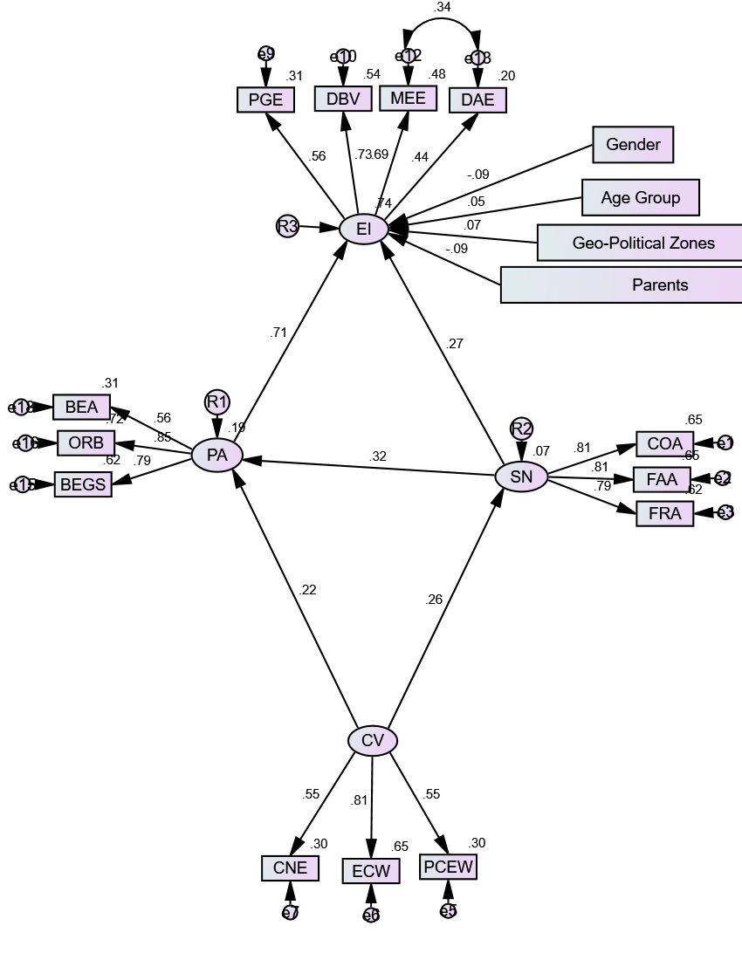

Appendix 3: Final Structural Model tested for mediation
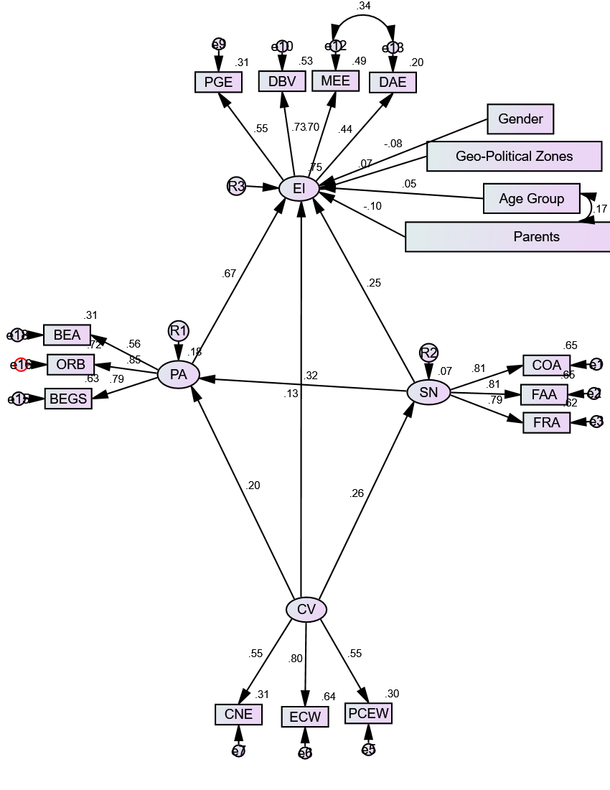

Appendix 4: Lower and upper bounds

Appendix 5: Standardized Direct Effects - Two Tailed Significance (BC) (Group number 1 - Default model)
 | Parents | Zones | Age_Group | Gender | CV | SN | PA | EI
SN | ... | ... | ... | ... | .001 | ... | ... | ...
PA | ... | ... | ... | ... | .007 | .001 | ... | ...
EI | .032 | .153 | .254 | .068 | .037 | .001 | .001 | ...
PA1 | ... | ... | ... | ... | ... | ... | .002 | ...
PA3 | ... | ... | ... | ... | ... | ... | .001 | ...
PA4 | ... | ... | ... | ... | ... | ... | .001 | ...
EI1 | ... | ... | ... | ... | ... | ... | ... | .001
EI2 | ... | ... | ... | ... | ... | ... | ... | .002
EI4 | ... | ... | ... | ... | ... | ... | ... | .002
EI5 | ... | ... | ... | ... | ... | ... | ... | .001
CV1 | ... | ... | ... | ... | .001 | ... | ... | ...
CV2 | ... | ... | ... | ... | .001 | ... | ... | ...
CV3 | ... | ... | ... | ... | .001 | ... | ... | ...
SN1 | ... | ... | ... | ... | ... | .001 | ... | ...
SN2 | ... | ... | ... | ... | ... | .002 | ... | ...
SN3 | ... | ... | ... | ... | ... | .001 | ... | ...

